Overview
This chapter deals with the most basic conceptsin finance: future value, present value,
and internal rate of return. These concepts tell you how much your money will grow if deposited in a bank (future value), how much promised future payments are worth today (present value), and what percentage rate of return you’re getting on yourinvestments (internal rate of return).
Financial assets and financial planning always have a time dimension. Here are some
simple examples:
• You put $100 in the bank today in a savings account. How much will you have in 3
years?
• You put $100 in the bank today in a savings account and plan to add $100 every year
for the next 10 years. How much will you have in the account in 20 years?
• XYZ Corporation just sold a bond to your mother for $860. The bond will pay her
$20 per year for the next 5 years. In 6 years she gets a payment of $1020. Has she
paid a fair price for the bond?
• Your Aunt Sara is considering making aninvestment. The investment costs $1,000
and will pay back $50 per month in each of the next 36 months. Should she do this or
should she leave her money in the bank, where it earns 5%?
This chapter discusses these and similar issues, all of which fall under the general topic of
time value of money. You will learn how compound interest causes invested income to grow
(future value), and how money to be received at futuredates can be related to money in hand
today (present value). You will also learn how to calculate the compound rate of return earned by an investment (internal rate of return). The concepts of future value, present value, and PFE Chapter 1, Time value of money page 3 internal rate of return underlie much of the financial analysis which will appear in the following chapters.
Finance concepts discussed
• Future value
• Present value
• Net present value
• Internal rate of return
• Pension and savings plans and other accumulation problems
Excel functions used
• Excel functions: PV, NPV, IRR, PMT, NPer
• Goal seek
1.1. Future value
Future value (FV) tells you the value in the future of money deposited in a bank account
today and left in the accountto draw interest. The future value $Xdeposited today in an account paying r%interest annually and left in the account for nyears is X*(1+r)^{n}
. Future value is our first illustration of compound interest—it incorporates the principle that you earn interest on interest. If this sounds confusing, read on.
PFE Chapter 1, Time value of money page 4
Suppose you put $100 in a savings account in your bank today and that the bank pays you
6% interest at the end of every year. If you leave the money in the bank for one year, you will
have $106 after one year: $100 of the original savings balance + $6 in interest.
Now suppose you leave the money in the account for a second year: At the end of this
year, you will have: $106 The savings account balance atthe end of the first year
+ 6%*$106 = $6.36 The interest in on thisbalance for the second year
= $112.36 Total in account after two years
A little manipulation will show you that the future value of the $100 after 2 years is
$100*(1+6%)²
Year 1's future Year 2's Initial deposit value factor at 6% future value factor
Future value of $100 after one year = $100*1.06
Future value of $100 after two years $100* (1+ 6%) * 1.06 = $112.36
Notice that the future value uses the concept of compound interest: The interest earned in
the first year ($6) itself earns interest in the second year. To sum up:
The value of $X deposited today in an account paying r% interest annually and left in the
account for n years is its future value FV = X(1+r )^{n}
Notation
In this book we will often match our mathematical notation to that used by Excel. Since
in Excel multiplication is indicated by a star “*”, we will generally write 6%*$106 = $6.36, even though this is not necessary. Similarly we will sometimes write ( ) 1.10³ as 1.10 ^ 3.
In order to confuse you, we make no promises about consistency!
Future value calculations are easily done in Excel:
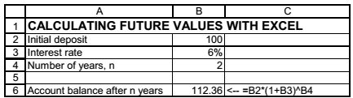
Notice the use of the carat (^) todenote the exponent: In Excel
(1+6%)² is written as (1+B3)^B4, where cell B3 contains the interest rate and cell B4 the number of years.
We can use Excel to make a table of how the future value grows with the years and then
use Excel’s graphing abilities to graph this growth:
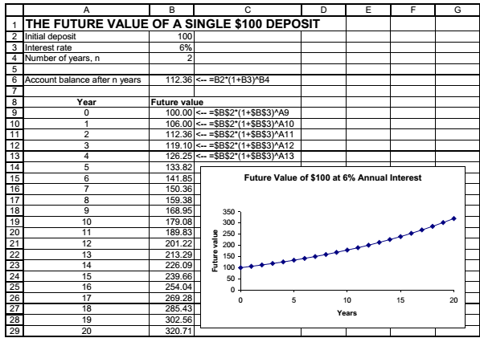
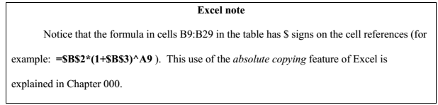
In the spreadsheet below, we present a table and graph that shows the future value of
$100 for 3 different interest rates: 0%, 6%, and 12%. As the spreadsheet shows, future value is verysensitive to the interest rate! Note that when the interest rate is 0%, the future value doesn’t grow.
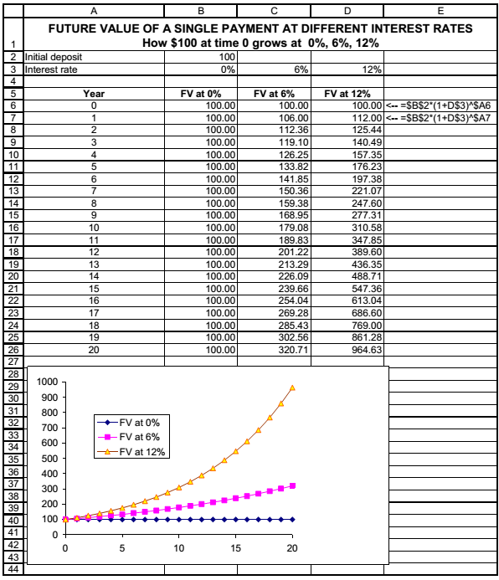
Nomenclature: What’s a year? When does it begin?
This is a boring but necessary discussion. Throughout this book we will use the
following synonyms:
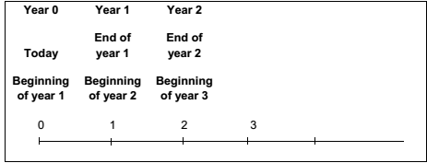
We use the words “Year 0,” “Today,” and “Beginning of year 1” as synonyms. This often causes confusion in finance. For example, “$100 at the beginning of year 2” is the same as “$100 at the end of year 1.” Note that we often use “in year 1” to mean“end of year 1”: For example: “An investment costs $300 today and pays off $600 in year 1.”
There’s a lot of confusion on this subject in finance courses and texts.If you’re at loss to understand what someone means, ask for a drawing; better yet, ask for an Excel spreadsheet.
Accumulation—savings plans and future value
In the previous example you deposited $100 and left it in your bank. Suppose that you intend to make 10 annual deposits of $100, with the first deposit made in year 0 (today) and each succeeding deposit made at the end of years 1, 2, ..., 9. The future valueof all these deposits at the end of year 10 tells you how much you will have accumulated inthe account. If you are saving for the future (whether to buy a car at the end of your college years or to finance a pension at the end of your working life), thisis obviously an important and interesting calculation.
So how much will you have accumulated atthe end of year 10? There’s an Excel function for calculating this answer which we will discuss later; for the moment we will set this problem up in Excel and do our calculation the longway, by showing how much we will have at the end of each year:
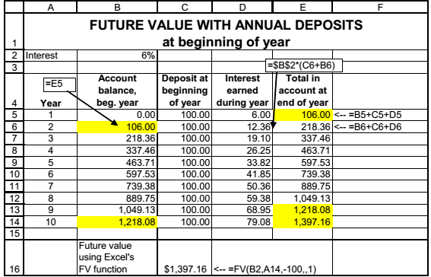
For clarity, let’s analyze a specific year: At the end of year 1 (cell E5) you’ve got $106 in the account. This is also the amount in the account at the beginning of year 2 (cell B6). If you now deposit another $100 and let the whole amount of $206 draw interest during the year, it will earn $12.36 interest. You will have $218.36= (106+100)*1.06 at the end of year 2.
Finally, look at rows 13 and 14: At the end of year 9 (cell E13) you have $1,218.08 in the account; this is also the amount in the account at the beginning of year 10 (cell B14). You then deposited $100 and the resulting $1,318.08 earns $79.08 interest during the year, accumulating to $1,397.16 by the end of year 10.
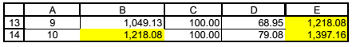
The Excel FV (future value) formula
The spreadsheet of the previous subsection illustrates in a step-by-step manner how money accumulates in a typical savings plan. To simplify this series of calculations, Excel has a FVformula which computes the future value of any series of constant payments. This formula is illustrated in cell C16:
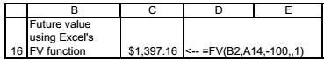
The FVfunction requires as inputs the Rateof interest, the number of periods Nper, and the annual payment Pmt. You can also indicate the Type, which tells Excel whether payments are made at the beginning of the period (type 1as in our example) or at the end of the period
(type 0).
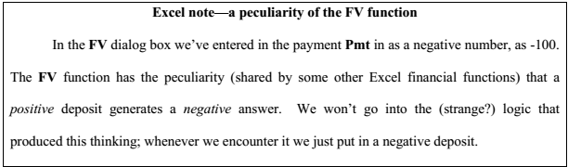
Sidebar: Functions and Dialog Boxes
The dialog box which comes with an Excel function is a handy way to utilize the function. There are several ways to get to a dialog box. We’ll illustrate with the example of the FV function in Section 1.1.
Going through the function wizard
Suppose you’re in cell B16 and you want to put the Excel function for futurevalue in the cell.
With the cursor in B16, you move your mouse to the icon on the tool bar:

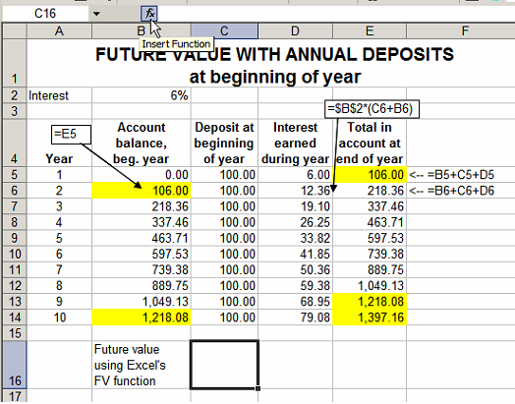
Clicking on the fx icon brings up the dialog box below. We’ve already chosen the categoryto be the Financialfunctions, and we’ve scrolled downin the next section of the dialog box to put the cursor on the FVfunction.
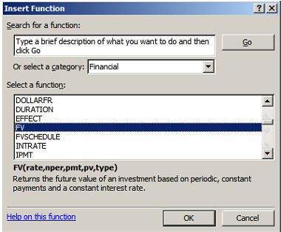
Clicking OK brings up the dialog box for the FVfunction.
A short way to get to the dialog box
If you know the name of the function you want, you can just write it in the cell and then click the fx icon on the tool bar. As illustrated below, you have to write
=FV(
and then click on the fx icon—note that we’ve written an equal sign, the name of the function, and the opening parenthesis.
Here’s how the spreadsheet looks in this case:
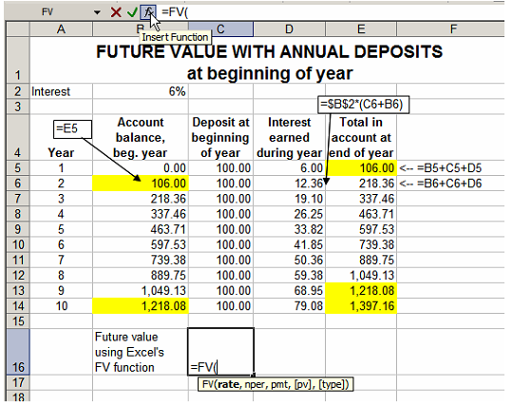
Look in the text displayed by Excel below cell C16: Some versions of Excel show the format of the function when you type it in a cell.
One further option
You don’t have to use a dialogbox! If you know the format of the function then just type in its arguments and you’re all set. In the example of Section 1.1 you could just type =FV(B2,A14,-100,,1)in the cell. Hitting [Enter] would give the answer.
[END OF SIDEBAR]
Beginning versus end of period
In the example above you make deposits of $100 at the beginningof each year. In terms of timing, your deposits are made at dates 0, 1, 2, 3, ..., 9. Here’s a schematic way of looking at this, showing the future value of each deposit at the end of year 10:

